**IT24103028**

**Probability and Statistics – IT2120**

**Lab05**

Q1. Import the dataset (’Exercise – Lab 05.txt’) into R and store it in a data frame

called ”Delivery Times”.

Q2. Draw a histogram for deliver times using nine class intervals where the lower limit is 20 and upper limit is 70. Use right open intervals.

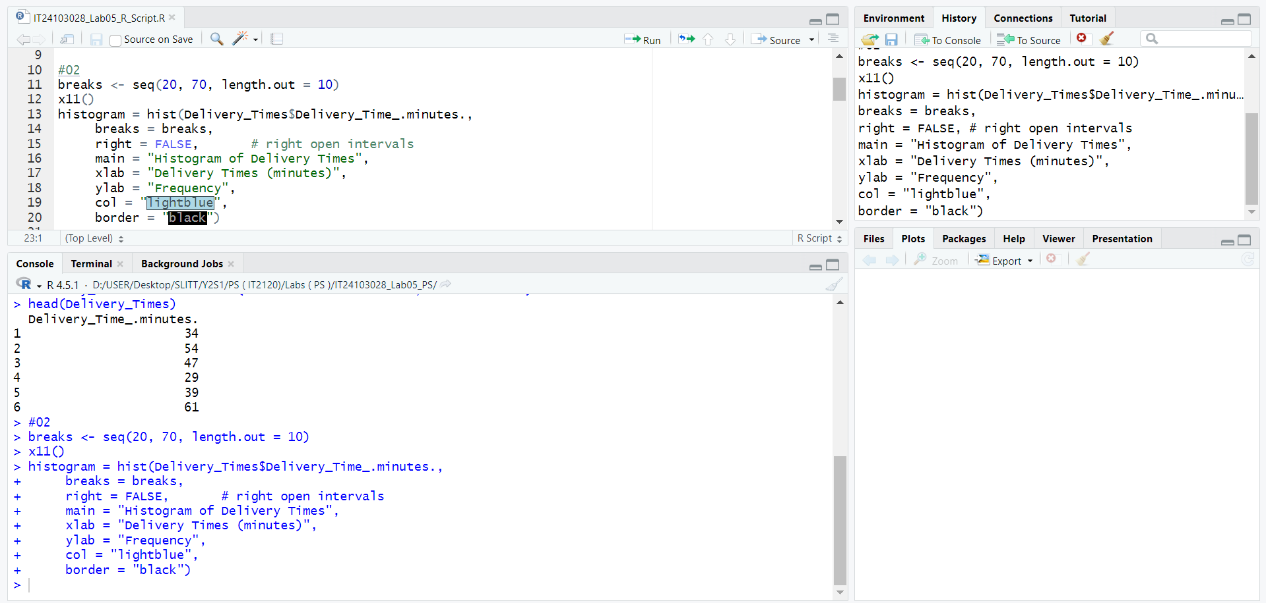

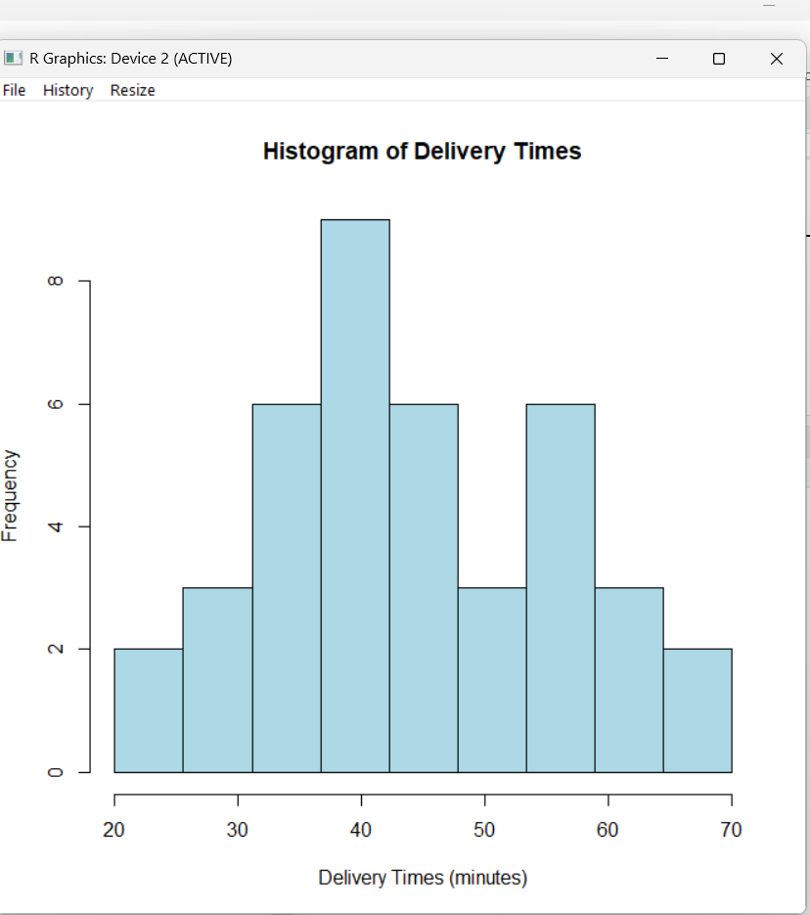

Q3. Comment on the shape of the distribution.

The distribution of delivery times is approximately symmetric and resembles a bell-shaped curve centered around 40 minutes.

Q4. Draw a cumulative frequency polygon (ogive) for the data in a separate plot.

